🟢 Bandit Level 2 → Level 3
After logging in as bandit2, run:
ls -al to view the hidden files
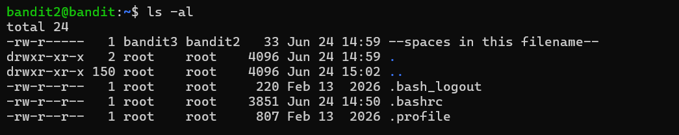
You'll see:
--spaces in this filename—
Then cat "./--spaces in this filename--"
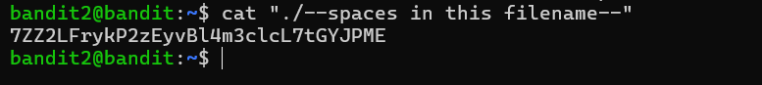

Then exit from that level

